**Topics: Normal distribution, Functions of Random Variables**

1. The time required for servicing transmissions is normally distributed with *μ* = 45 minutes and *σ* = 8 minutes. The service manager plans to have work begin on the transmission of a customer’s car 10 minutes after the car is dropped off and the customer is told that the car will be ready within 1 hour from drop-off. What is the probability that the service manager cannot meet his commitment?
2. 0.3875
3. 0.2676 #**Option B** is correct answer
4. 0.5
5. 0.6987

Ans: The work begin after 10 min, so the average time increase from 45min to 55min.

for normal distribution :-

z = (X-μ)/б

= (60-55)/8

= 0.625

Using the z-score, calculate the probability that the service time exceeds 60 minutes by subtracting the cumulative distribution function (CDF) value from 1.

As we want to find the probability of service manager cannot meet his commitment, So we should write below command.

#Using python

from scipy.stats import norm

nd = norm(55,8) # μ=55,sigma=8

1-nd.cdf(60) #0.2659855

1. The current age (in years) of 400 clerical employees at an insurance claims processing center is normally distributed with mean *μ* = 38 and Standard deviation *σ* =6. For each statement below, please specify True/False. If false, briefly explain why.
2. More employees at the processing center are older than 44 than between 38 and 44.
3. A training program for employees under the age of 30 at the center would be expected to attract about 36 employees.

Ans: Both the statements are True

A) We have a normal distribution with μ= 38 and σ = 6.

Let X be the number of employees. So according to question.

#Probabilty of employees greater than age of 44

= P(X>44)P(X > 44)

= 1 -P(X ≤ 44).

Z = (X -μ)/ σ

= (X -38)/6.

Thus the question can be answered by using the normal table to find P(X ≤ 44)

= P(Z ≤ (44 -38)/6)

= P(Z ≤ 1)=84.1345%

Probabilty that the employee will be greater than age of 44 = 100-84.1345=15.86%

So the probability of number of employees between 38-44 years of age

= P(X<44)-0.5

=84.1345-0.5

= 34.1345%

Therefore the statement that “More employees at the processing center are older than 44 than between 38 and 44” is TRUE.

B) Probabilty of employees less than age of 30 = P(X<30).

Z = (X -μ)/ σ

= (30 -38)/6

Thus the question can be answered by using the normal table to find P(X ≤ 30)

= P(Z ≤ (30 -38)/6)

= P(Z ≤ -1.333)

=9.12%

So the number of employees with probability 0.912 of them being under age 30 =0.0912*400

=36.48( or 36 employees).

Therefore the statement B of the question is also TRUE.

1. If *X1* ~ *N*(μ, σ2) and *X*2 ~ *N*(μ, σ2) are *iid* normal random variables, then what is the difference between 2 *X*1 and *X*1 + *X*2? Discuss both their distributions and parameters.

Ans:

The difference between the random variables 2X1 and X1 + X2, where X1 and X2 are independent and identically distributed (i.i.d.) normal random variables with mean μ and variance σ².

**Distribution of 2X1:**

If X1 ~ N(μ, σ²), then 2X1 ~ N(2μ, 4σ²).

The mean of 2X1 is 2μ.

The variance of 2X1 is 4σ².

**Distribution of X1 + X2:**

Since X1 and X2 are i.i.d., X1 + X2 follows a normal distribution with mean μ + μ = 2μ and variance σ² + σ² = 2σ².

Therefore, X1 + X2 ~ N(2μ, 2σ²).

The mean of X1 + X2 is 2μ.

The variance of X1 + X2 is 2σ².

In summary, both 2X1 and X1 + X2 have the same mean (2μ) but different variances. 2X1 has a variance of 4σ², while X1 + X2 has a variance of 2σ².

1. Let X ~ N(100, 202). Find two values, *a* and *b*, symmetric about the mean, such that the probability of the random variable taking a value between them is 0.99.
2. 90.5, 105.9
3. 80.2, 119.8
4. 22, 78
5. 48.5, 151.5 **Option D** is correct
6. 90.1, 109.9

Ans:

Convert the problem to the standard normal distribution:

We know that the standard normal distribution has a mean (μ) of 0 and a standard deviation (σ) of 1.

To transform X ~ N(100, 20^2) into the standard normal distribution, we use the formula:

Z = (X - μ) / σ

In this case, μ = 100 and σ = 20. So, we have:

Z = (X - 100) / 20.

We can use a standard normal distribution table or calculator to find the Z-scores corresponding to the cumulative probability of 0.005 and 0.995 (since we want the middle 99% of the distribution).

Z_a = Z-score for P(Z < 0.005)

Z_b = Z-score for P(Z < 0.995)

Transform Z_a and Z_b back to the original distribution:

Once you have Z_a and Z_b, you can transform them back to the original distribution using the formula:

X = Z * σ + μ

In this case, σ = 20 and μ = 100. So, you have:

a = Z_a * 20 + 100

b = Z_b * 20 + 100

Now, calculate a and b using the Z-scores obtained in step 2:

Using python

import scipy.stats as stats

# Find Z-scores for P(Z < 0.005) and P(Z < 0.995)

Z_a = stats.norm.ppf(0.005)

Z_b = stats.norm.ppf(0.995)

# Transform Z_a and Z_b back to the original distribution

sigma = 20

mu = 100

a = Z_a * sigma + mu

b = Z_b * sigma + mu

print("a =", a) # a = 48.483413929021985

print("b =", b) # b = 151.516586070978

1. Consider a company that has two different divisions. The annual profits from the two divisions are independent and have distributions Profit1 ~ N(5, 32) and Profit2 ~ N(7, 42) respectively. Both the profits are in $ Million. Answer the following questions about the total profit of the company in Rupees. Assume that $1 = Rs. 45
2. Specify a Rupee range (centered on the mean) such that it contains 95% probability for the annual profit of the company.
3. Specify the 5th percentile of profit (in Rupees) for the company
4. Which of the two divisions has a larger probability of making a loss in a given year?

Ans:

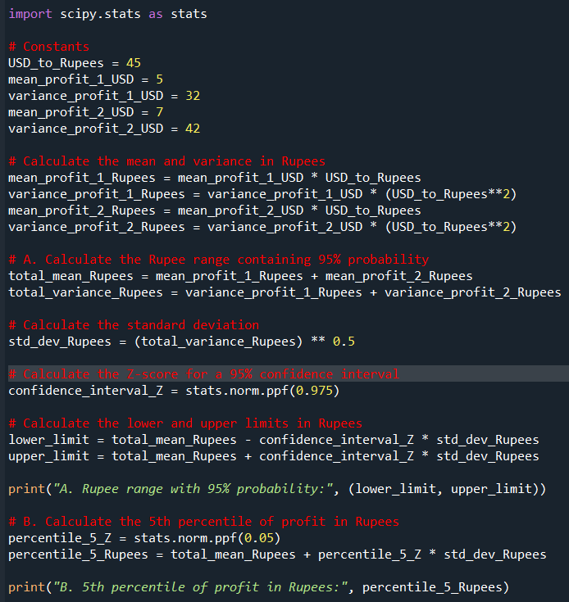

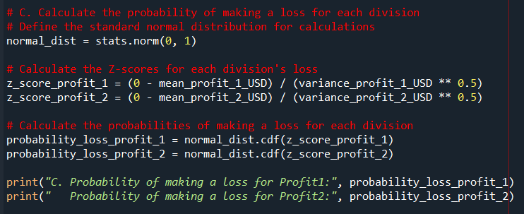

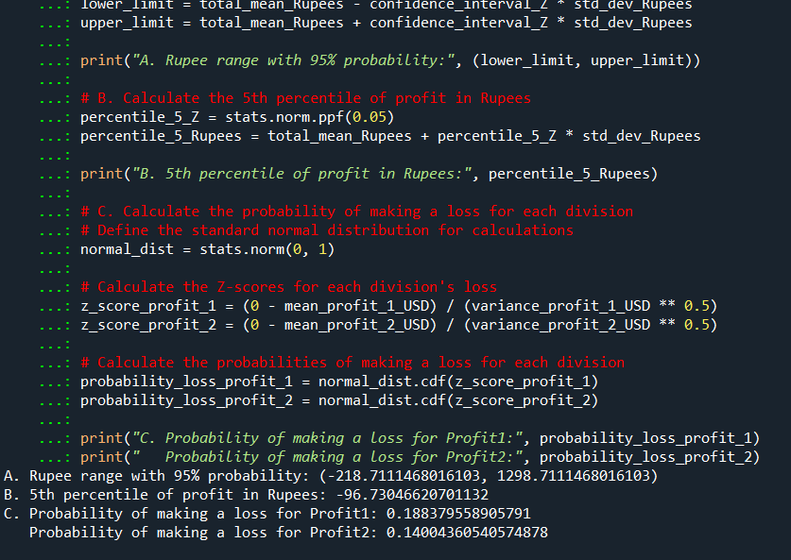

We first convert the means and variances from USD to Rupees.

For part A, we calculate the mean and standard deviation of the total profit in Rupees and then find the Z-score for a 95% confidence interval.

For part B, we calculate the Z-score for the 5th percentile and use it to find the 5th percentile of profit in Rupees.

For part C, we calculate the Z-scores for each division's loss and use the cumulative distribution function (CDF) of the standard normal distribution to find the probability of making a loss for each division.

A. Rupee range with 95% probability: (-218.7111468016103, 1298.7111468016103)

B. 5th percentile of profit in Rupees: -96.73046620701132

C. Probability of making a loss for Profit1: 0.188379558905791

Probability of making a loss for Profit2: 0.14004360540574878